CONTENT SEARCH

* **Assign Permissions**

<https://docs.microsoft.com/en-us/microsoft-365/compliance/assign-ediscovery-permissions>

* **Alternative: Assign Permissions in Powershell**

[Net.ServicePointManager]::SecurityProtocol = [Net.SecurityProtocolType]::Tls12  
  
Install-Module MSOnline;  
Connect-MsolService;  
Add-MsolRoleMember -RoleName "eDiscovery Administrator" `  
-RoleMemberEmailAddress ‘**admin@domain.com**‘;

* **Start a New Search**[**https://protection.office.com/contentsearchbeta**](https://protection.office.com/contentsearchbeta)

[**https://docs.microsoft.com/en-gb/microsoft-365/compliance/content-search**](https://docs.microsoft.com/en-gb/microsoft-365/compliance/content-search)

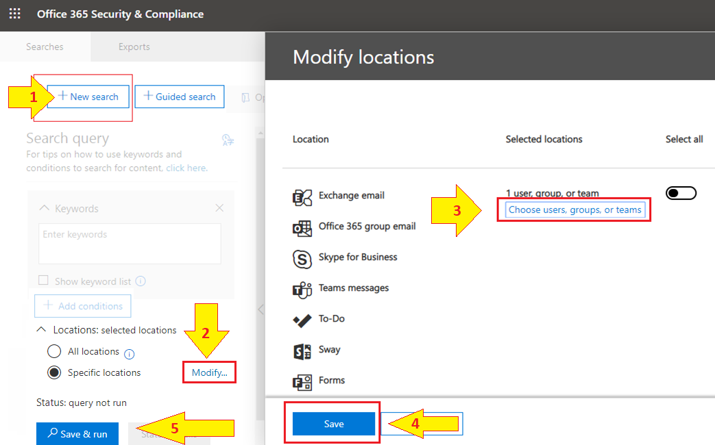

* **Also Specify the User (“Search Locations”)**
* **Start Search ( Save > Save & Run )**
* Prepare the Export PST – One PST for each Mailbox  
    
  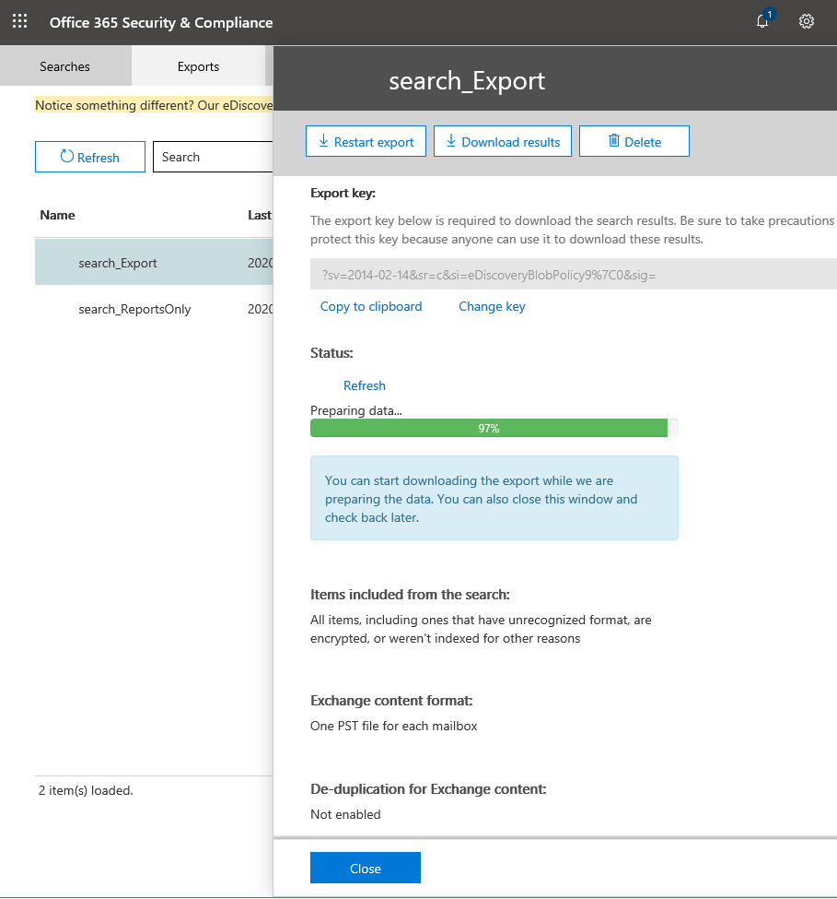
* When finished you can download the PST under Export (see permissions required)  
    
  